Name: Shailja kant Tiwari

Course:B.Sc(H)Physics Sem 5

Roll No.-081

AIM:To prove orthogonality of wav functions for a particle in a box and also to plot them.

SOURCE CODE:

clc;

clear;

clf;

i=4

f=8

L=f-i

n=input("Enter n:")

m=input("Enter m:")

function **y**=f1(**x**)

**y**=(sqrt(2/L)*sin(n*%pi\***x**/L))*(sqrt(2/L)*sin(m*%pi\***x**/L))

endfunction

i=intg(i,f,f1)

disp(clean(i))

x=i:0.01:f

a=(sqrt(2/L)*sin(n*%pi*x/L))

plot2d(x,a,2)

b=(sqrt(2/L)*sin(m*%pi*x/L))

plot2d(x,b,3)

legends(['n='+string(n)+':';'m='+string(m)+':'],[2,3])

OUTPUT:

Enter n:1

Enter m:2

0.

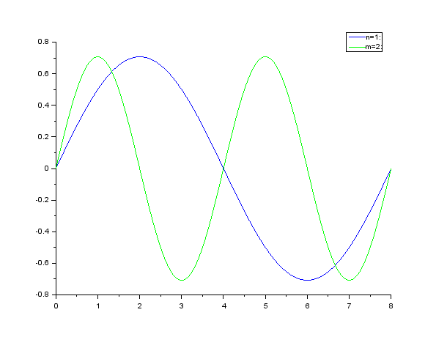

Enter n:1

Enter m:1

1.

